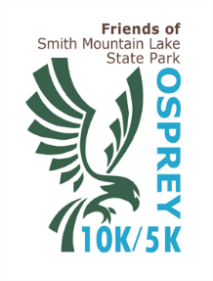
OSPREY 10K RUN/5K RUN-WALK
9 AM, Oct.10, 2020

Fee: $30 before 9/15, $35 after 9/15* and on Race Day

Cash & Check only on Race day

Fee includes: entrance to the State Park, chip timing, t-shirt*, and medals for category winners

*Race Shirts not guaranteed for registrations received after 9/25

Awards for male & female age group runners

Packet pick-up, Saturday, Oct 10 (Race Day): 7 – 8:30 AM at Smith Mountain Lake State Park

Name Sex M or F, Age DOB

Address________________________________ State_____ Zip____________

Phone Email: __________________________________

Emergency contact name: _____________________________________& phone ________________

Indicate shirt size: small________ medium, _________ large, __________ extra-large ______________

Circle Event: 10K Run or 5K Run/walk

Make Check Payable to: Friends of SML State Park, Inc.

Mail to: Friends of Smith Mountain Lake State Park
1235 State Park Road
Huddleston, VA 24104
ATTN: JANIS ERICKSON

Read and Sign:
I know running a race is a potentially hazardous activity and requires proper training. I should not run unless I am medically able to safely complete the race. I agree to abide by race directions. I do hereby for myself, my heirs, my executors, administrators and assignees, release and forever discharge the Friends of Smith Mountain Lake State Park Inc., its sponsors and all others staffing this event from all claims of any kind or nature as a result of my participation in this event.

SIGN_____________________________________

